Student’s First Name
Student’s Surname
Gender | Male / Female
Home address
Home University
Course of Study
Year of Study
Email address
Emergency contact name (for whilst at the Summer School)
Emergency contact phone number
Emergency contact email address
Please let us know of any dietary requirements you have or any medical information we should be aware of
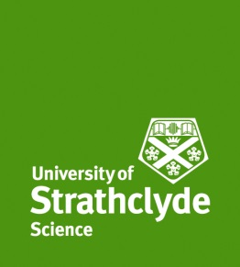
University of Strathclyde
Summer School for Students from China 2019

Once completed this application form should be returned to science-enquiries@strath.ac.uk
Any questions you have about the Summer School should also be directed to this email address.

The application deadline is Friday 10 February 2017. You will be informed if your application has been successful and your place secured by Friday 31 March 2019.

